Scalable 3-Tier Web Application on AWS
(Designing Robust Web Application on AWS)

Summary: This AWS architecture diagram shows a reliable web application built with three parts. Users find the application through Route 53, a DNS service. The application is protected in a virtual private network (VPC) on AWS, spread across different availability zones to ensure it keeps working even if one zone fails. The user-facing part of the application uses multiple servers (EC2 Instances) for better performance, with an Application Load Balancer (ALB) sharing the traffic evenly. The business logic is handled in another part, possibly using a database service. Data is securely stored in a separate part, using a database service RDS. This setup provides a strong base for web applications on AWS, with the flexibility to add more services for advanced features.

Part 1 :- VPC Construct
- Create a VPC named awsProject-vpcwith a CIDR block of 20.0.0.0/20.
- web-pub-sub1with CIDR block 20.0.1.0/24in us-east-1a
- web-pub-sub2with CIDR block 20.0.2.0/24in us-east-1b
- Create 2 public subnets:
- app-pvt-sub1with CIDR block 20.0.3.0/24in us-east-1a
- app-pvt-sub2with CIDR block 20.0.4.0/24in us-east-1b
- Create 2 private subnets for applications:
- db-pvt-sub1with CIDR block 20.0.5.0/24in us-east-1a
- •db-pvt-sub2with CIDR block 20.0.6.0/24in us-east-1b
- Create 2 private subnets for databases:
- Create a NAT Gateway named my-nat, provide the subnet as web-pub-sub1, and allocate an Elastic IP.
- Create an Internet Gateway named my-igwand attach it to the VPC awsProject-vpc.
- Create 3 route tables named route-web, route-app, and route-db.
- Associate the subnets with the route tables as follows:
- Select route-weband associate it with the subnets web-pub-sub1and web-pub-sub2.
- Select route-appand associate it with the subnets app-pvt-sub1and app-pvt-sub2.
- Select route-dband associate it with the subnets db-pvt-sub1and db-pvt-sub2.

Now add the routes Select route-web, go to routes and click edit routes, add route select the Destination as 0.0.0.0/0, Target Internet Gateway(my-igw) and click on save changes
Select route-app, go to routes and click edit routes, add route select the Destination as 0.0.0.0/0, Target NAT Gateway(my-nat) and click on save changes
Select route-db, go to routes and click edit routes, add route select the Destination as 0.0.0.0/0, Target NAT Gateway(my-nat) and click on save changes
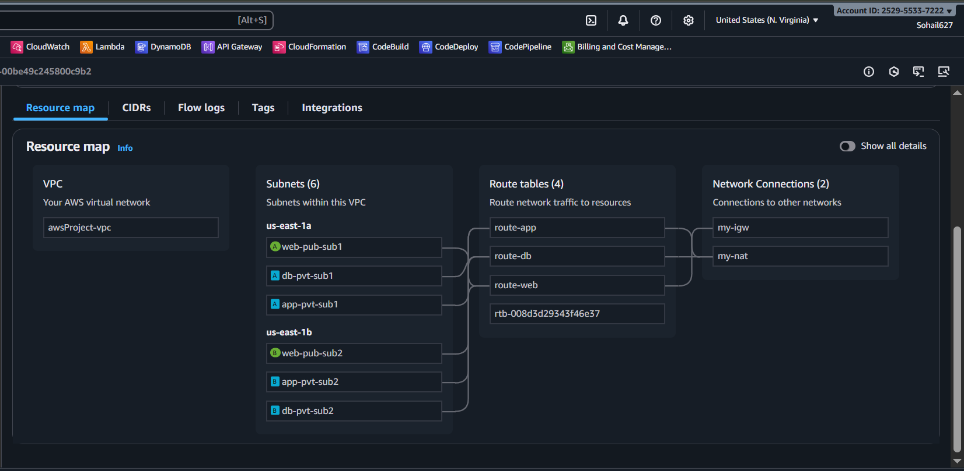
Part 2 :- Ec2 Instances
Create 3 EC2 instances in which 1 in public subnet with publicIP enable which acts as Jump server or bastion host and 2 private subnet with publicIP disable in which we will download phpMyAdmin and apache server
- Launch an Instance with name jump-server, AMI (Amazon Linux), Instance type (t2.micro), Create a new keypair as (projectkey) , click on edit button on right side of Network settings select vpc(awsProject-vpc), Subnet (web-pub-sub1), Auto-assign IP (Enable), Create security group [Security group name (jump-sg)], allow port SSH (22) and HTTP (80) now Launch instance
- Create a security group as alb-sg and allow port HTTP (80)
- Launch an Instance with name app-server1, AMI (Amazon Linux), Instance type (t2.micro), Select the keypair as (projectkey) , click on edit button on right side of Network settings select vpc (awsProject-vpc), Subnet (app-pvt-sub1 ), Auto-assign IP (Disable), Create security group [Security group name (app-sg)], allow port SSH (22) and Click on Add security group rule select Type (All traffic , ) Source type (Custom) and Source (here select your [alb-sg] you created) now Launch instance
- Launch an Instance with name app-server2, AMI (Amazon Linux), Instance type (t2.micro), Select the keypair as (projectkey) , click on edit button on right side of Network settings select vpc (awsProject-vpc), Subnet (app-pvt-sub2 ), Auto-assign IP (Disable), Select existing security group as (app-sg), now Launch instance
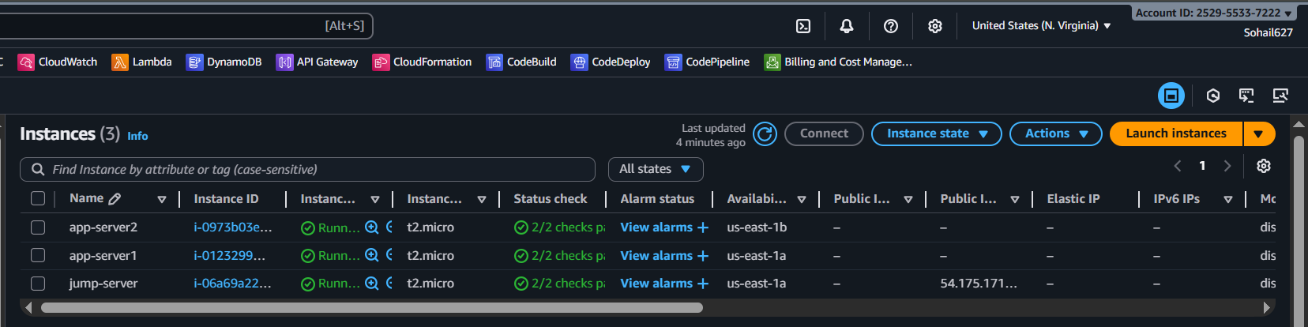
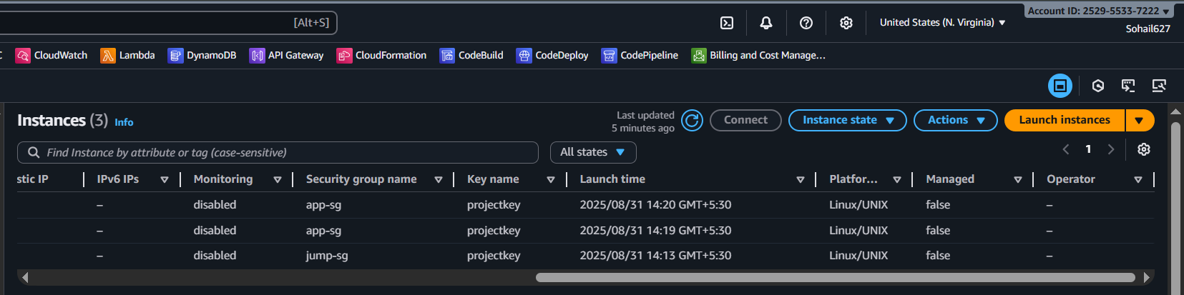

Part 3 :- Server configuration

- Copy the private key in your jump-server instance

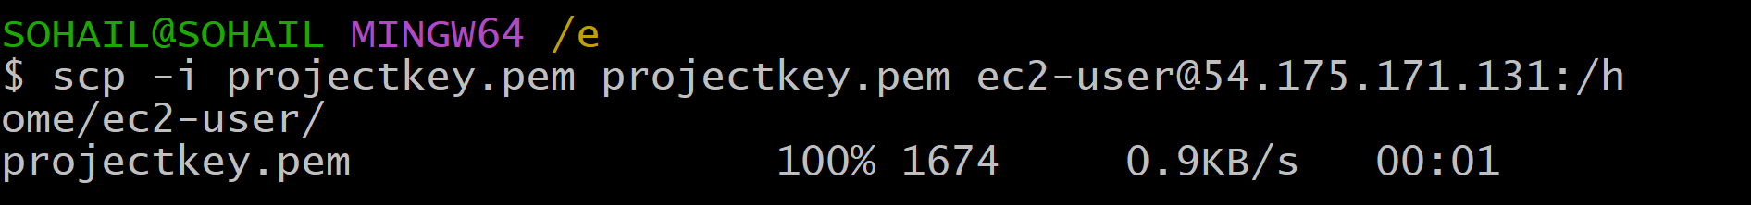
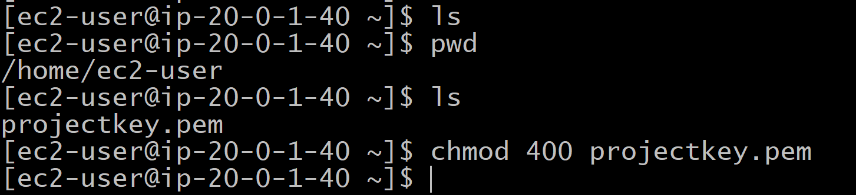

- Now ssh into app-server1 and run the below commands

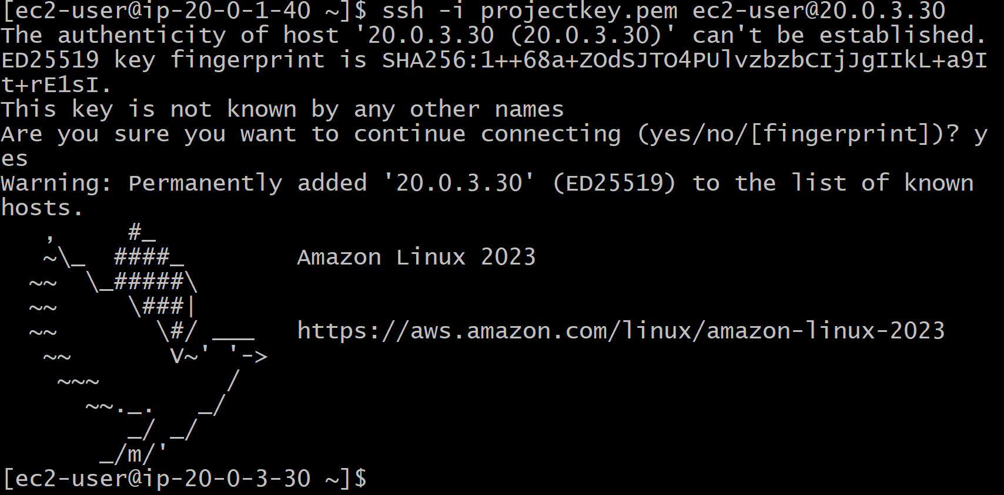
# Update the system
>> sudo yum update -y
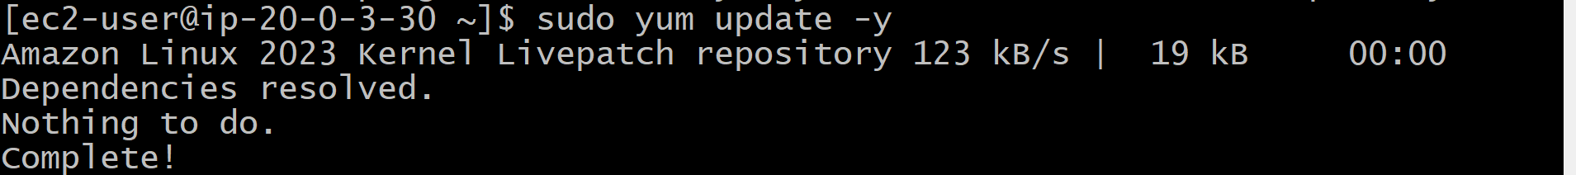
# Install PHP 8.2
>> sudo dnf install php8.2
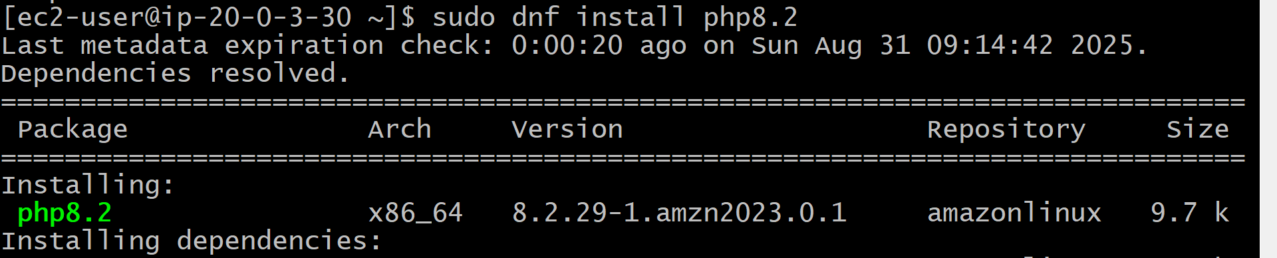
>> sudo yum install php8.2-mysqlnd
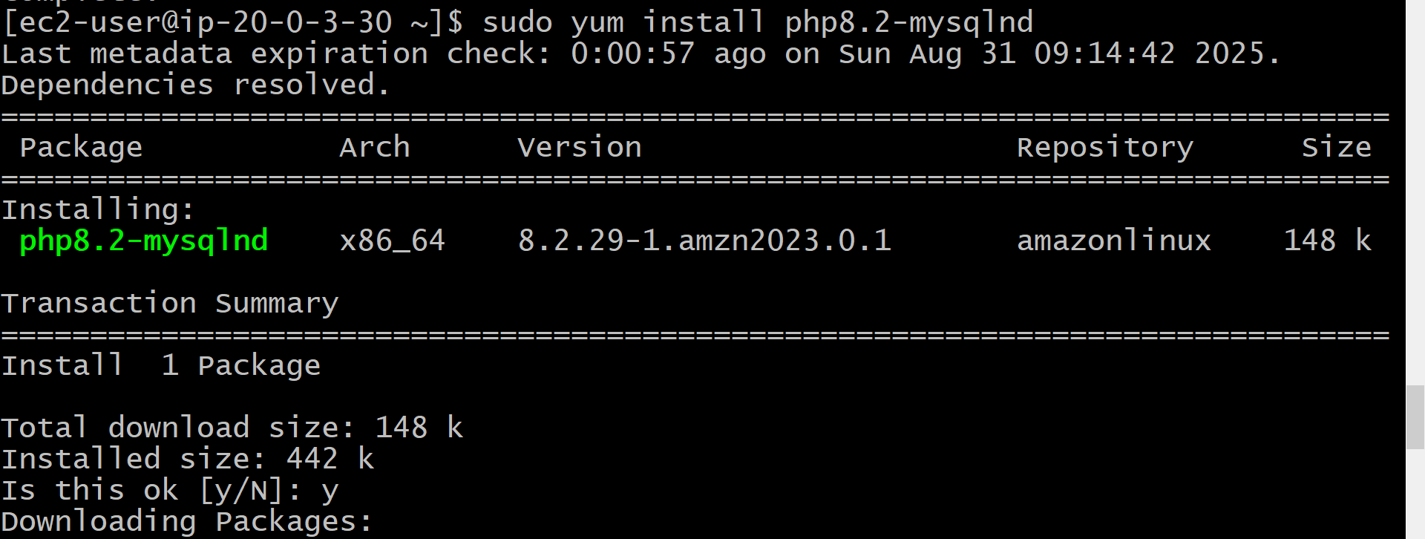

# Install Apache Web Server
>> sudo yum install -y httpd
# Start and Enable Apache
>> sudo systemctl start httpd
>> sudo systemctl enable httpd
>> sudo systemctl is-enabled httpd
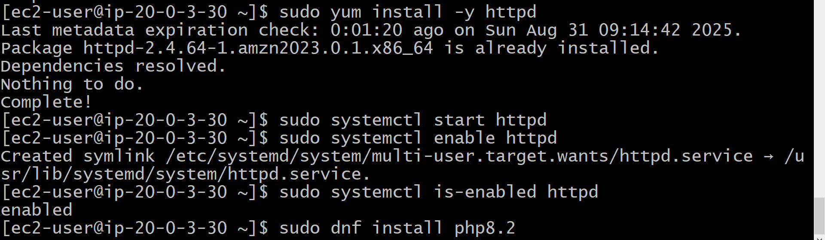
# Add User to Apache Group
>> sudo usermod -a -G apache ec2-user
# Change Ownership and Permissions for Web Directory
>> sudo chown -R ec2-user:apache /var/www
>> sudo chmod 2775 /var/www && find /var/www -type d -exec sudo chmod 2775 {} \;
>> find /var/www -type f -exec sudo chmod 0664 {} \;
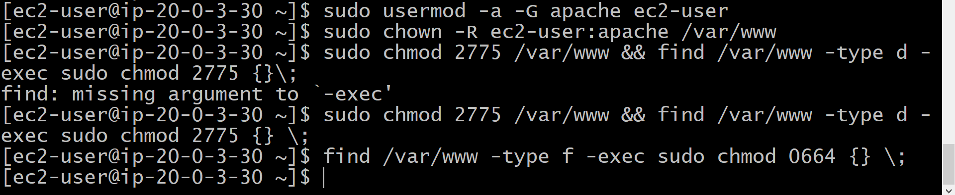
# Install Additional PHP Modules
>> sudo yum install php-mbstring php-xml -y
>> sudo yum install php-fpm
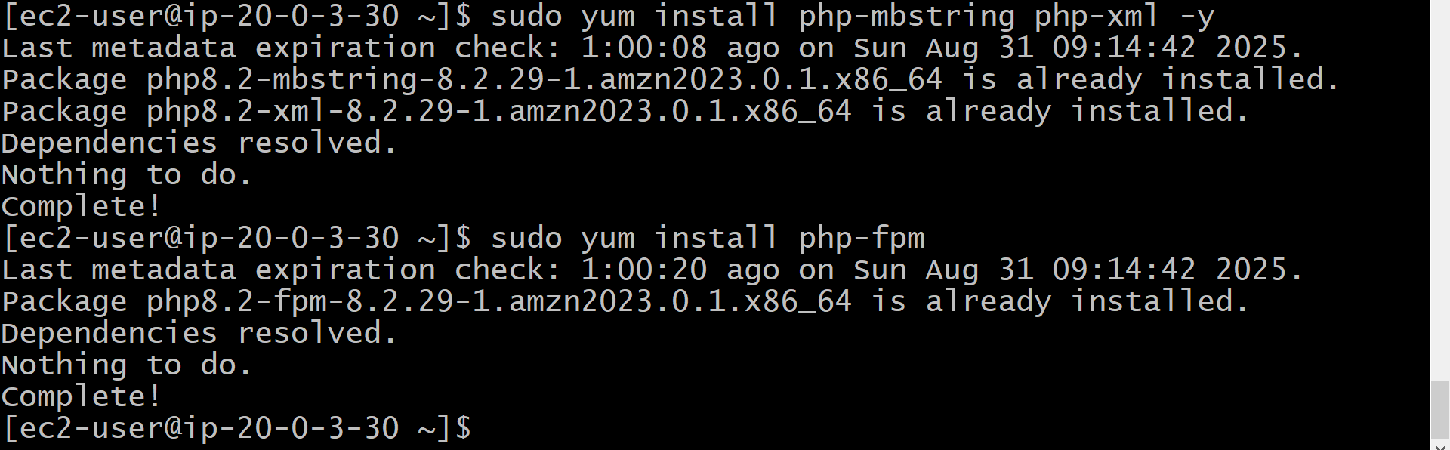
# Restart Apache and PHP-FPM
>> sudo systemctl restart httpd
>> sudo systemctl restart php-fpm
# Download and Set Up phpMyAdmin
>> cd /var/www/html
>> wget https://www.phpmyadmin.net/downloads/phpMyAdmin-latest-all-languages.tar.gz
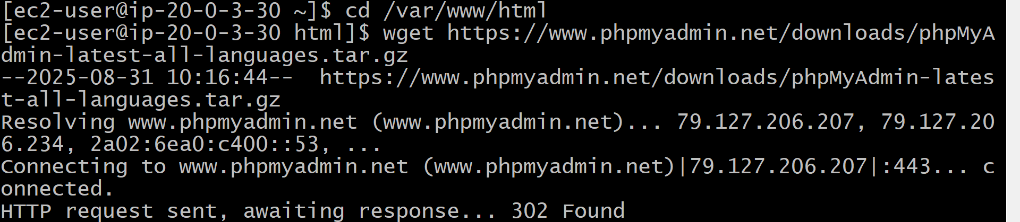

>> mkdir phpMyAdmin && tar -xvzf phpMyAdmin-latest-all-languages.tar.gz -C phpMyAdmin --strip-components 1
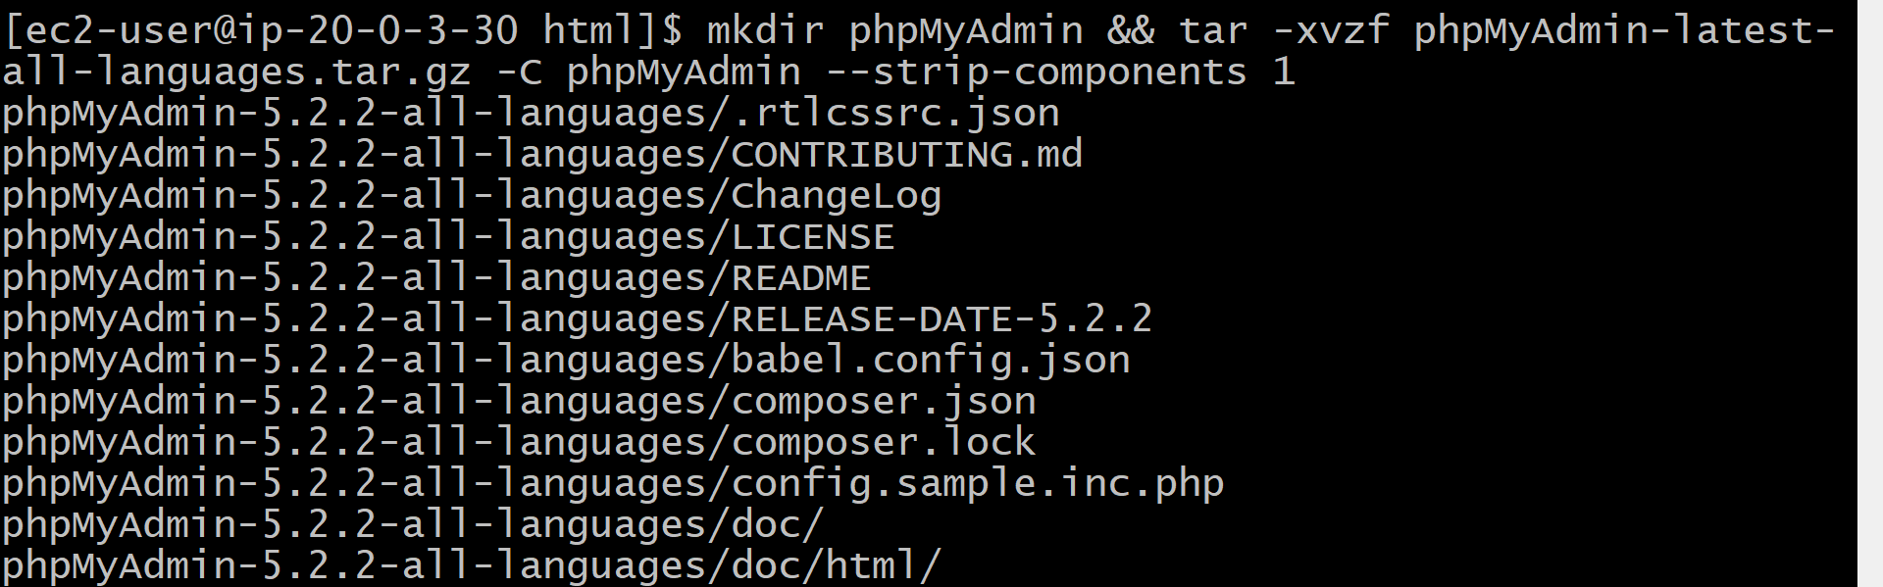
>> rm phpMyAdmin-latest-all-languages.tar.gz
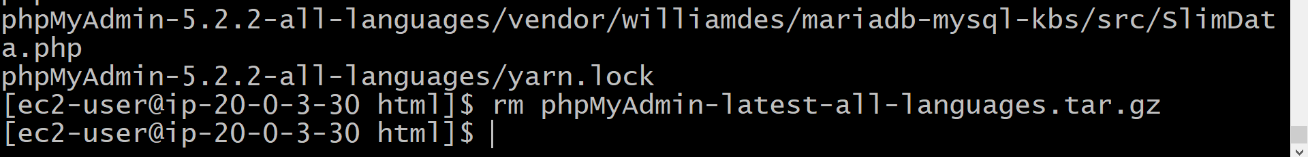
# Create a Test Page and Test the Server
>> echo "PHP server 1" > /var/www/html/index.html
>> curl http://localhost
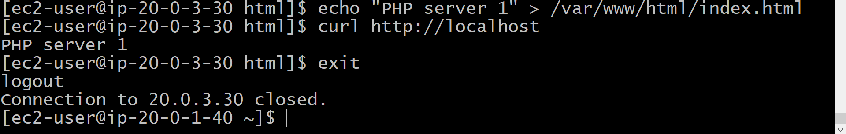
- Now ssh into app-server2 and run the below commands
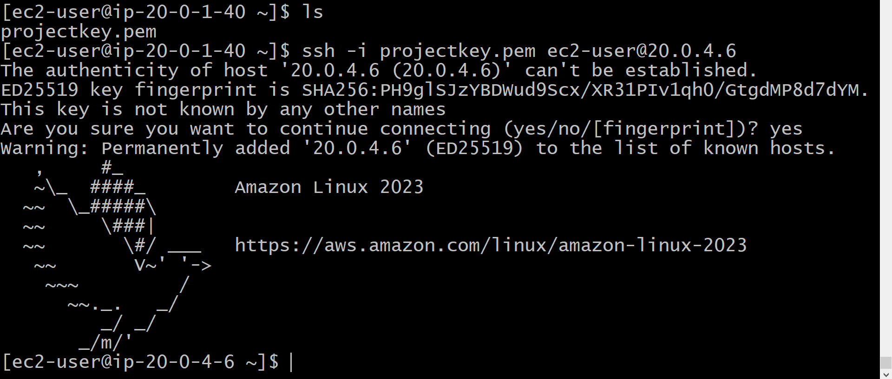
# Update the system
>> sudo yum update -y
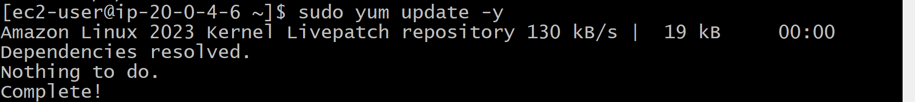
# Install PHP 8.2
>> sudo dnf install php8.2
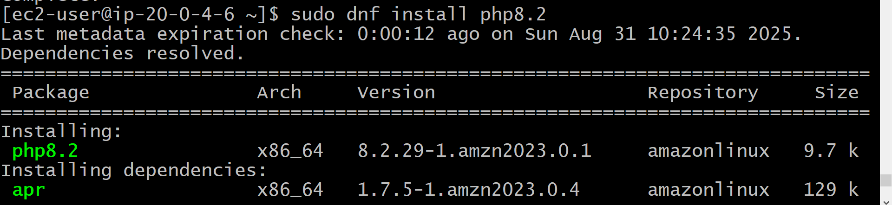

>> sudo yum install php8.2-mysqlnd
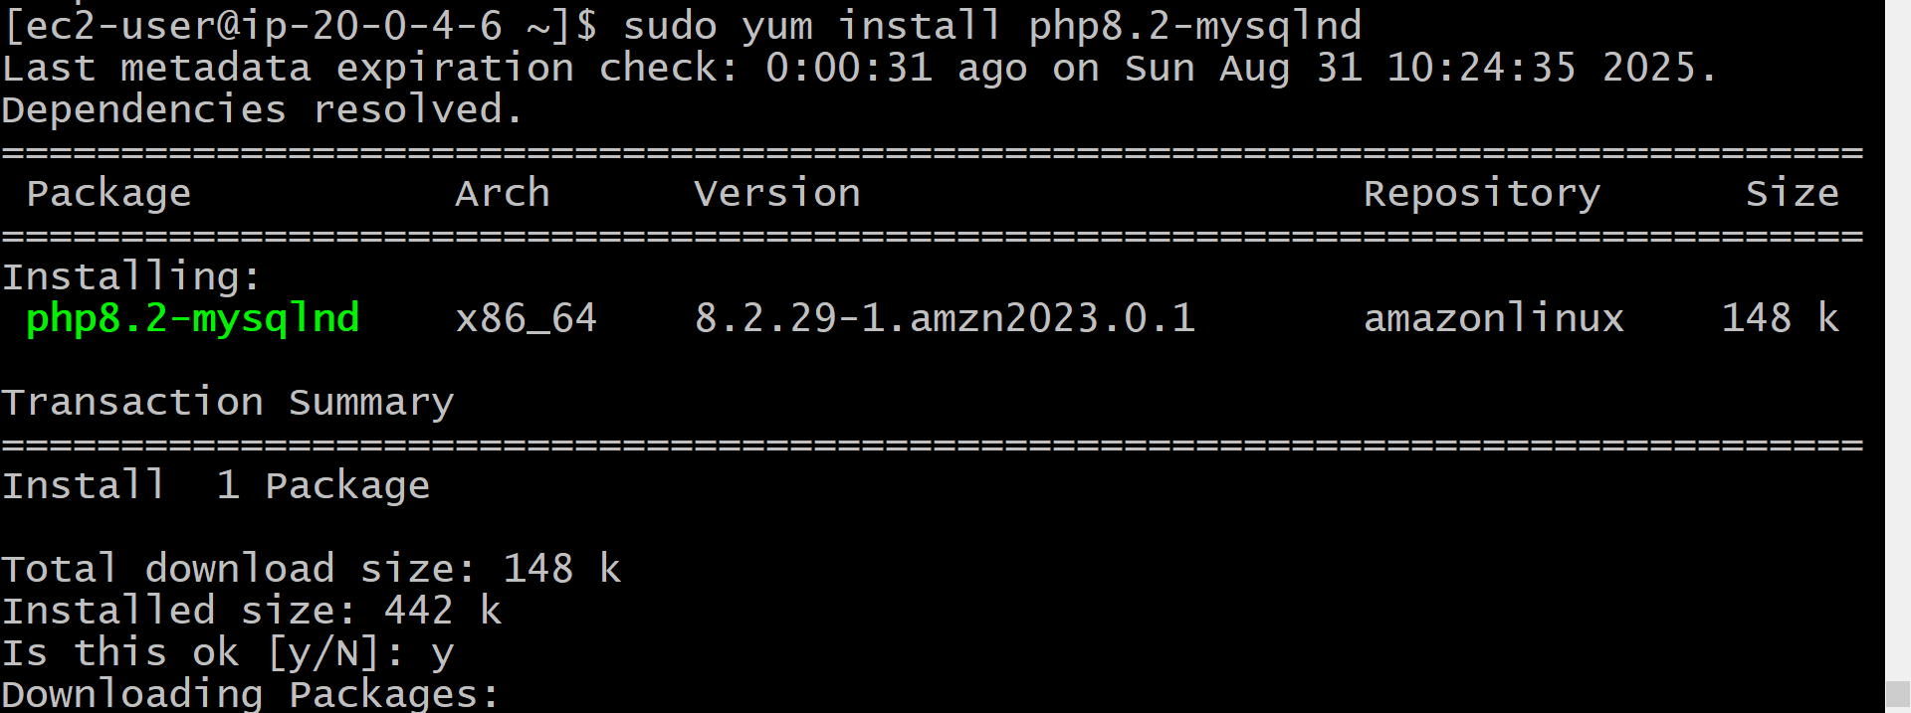
# Install Apache Web Server
>> sudo yum install -y httpd
# Start and Enable Apache
>> sudo systemctl start httpd
>> sudo systemctl enable httpd
>> sudo systemctl is-enabled httpd
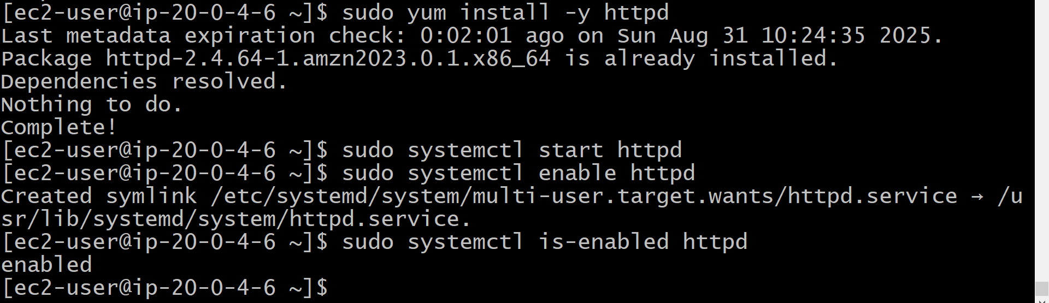
# Add User to Apache Group
>> sudo usermod -a -G apache ec2-user
# Change Ownership and Permissions for Web Directory
>> sudo chown -R ec2-user:apache /var/www
>> sudo chmod 2775 /var/www && find /var/www -type d -exec sudo chmod 2775 {} \;
>> find /var/www -type f -exec sudo chmod 0664 {} \;
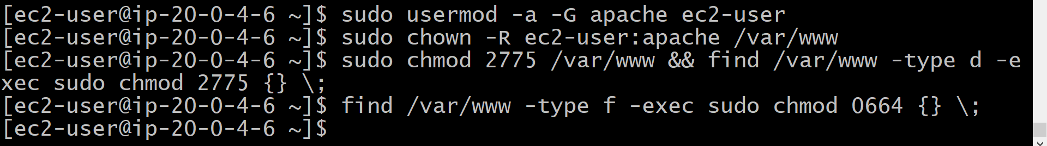
# Install Additional PHP Modules
>> sudo yum install php-mbstring php-xml -y
>> sudo yum install php-fpm
# Restart Apache and PHP-FPM
>> sudo systemctl restart httpd
>> sudo systemctl restart php-fpm
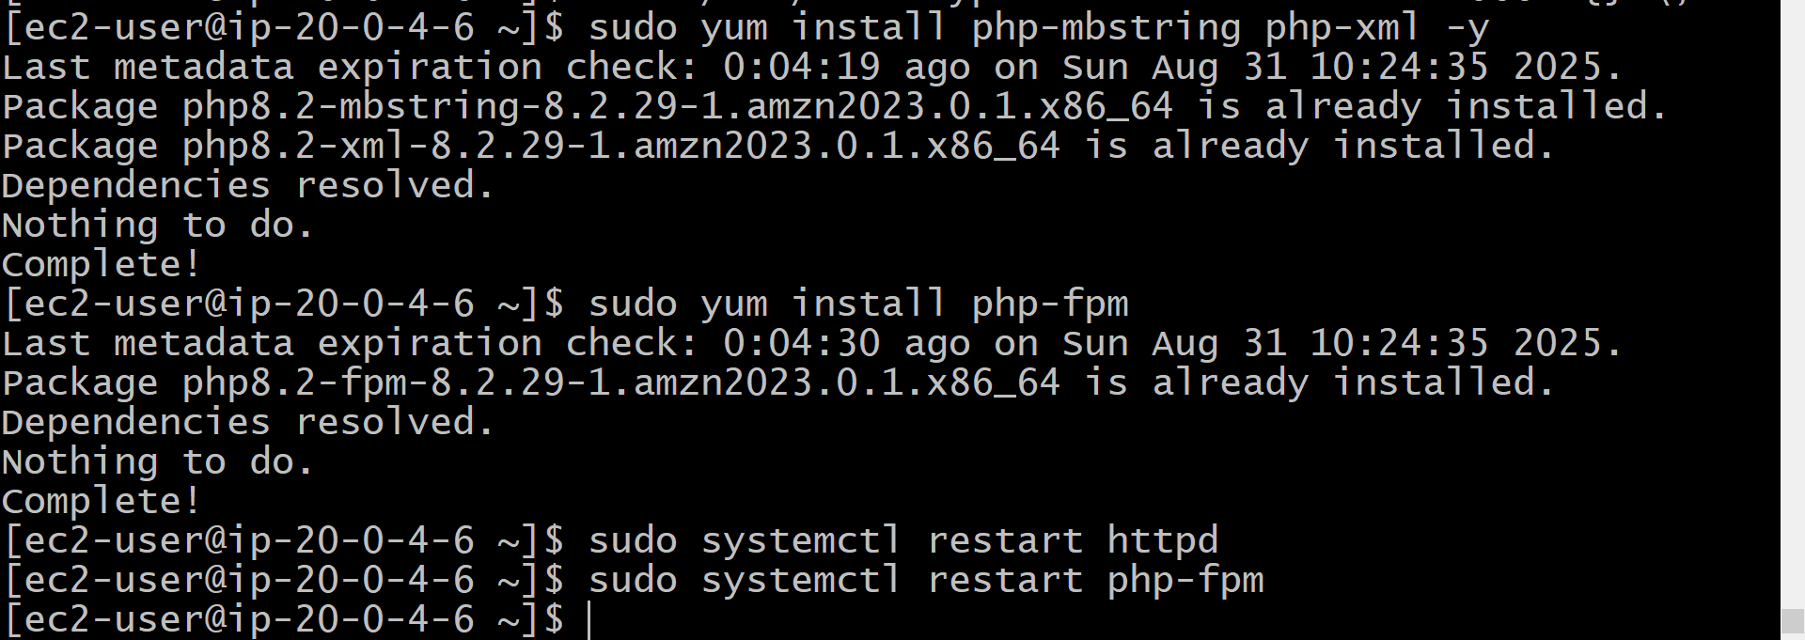
# Download and Set Up phpMyAdmin
>> cd /var/www/html
>> wget https://www.phpmyadmin.net/downloads/phpMyAdmin-latest-all-languages.tar.gz
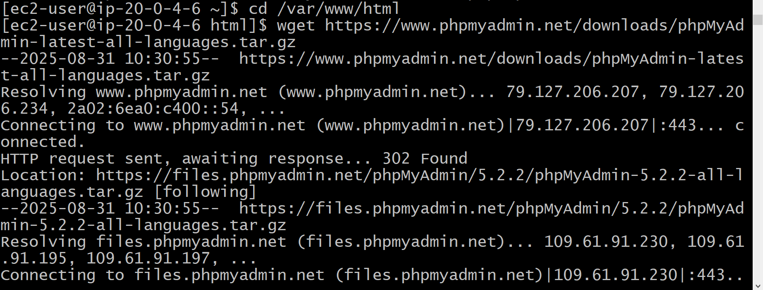

>> mkdir phpMyAdmin && tar -xvzf phpMyAdmin-latest-all-languages.tar.gz -C phpMyAdmin --strip-components 1
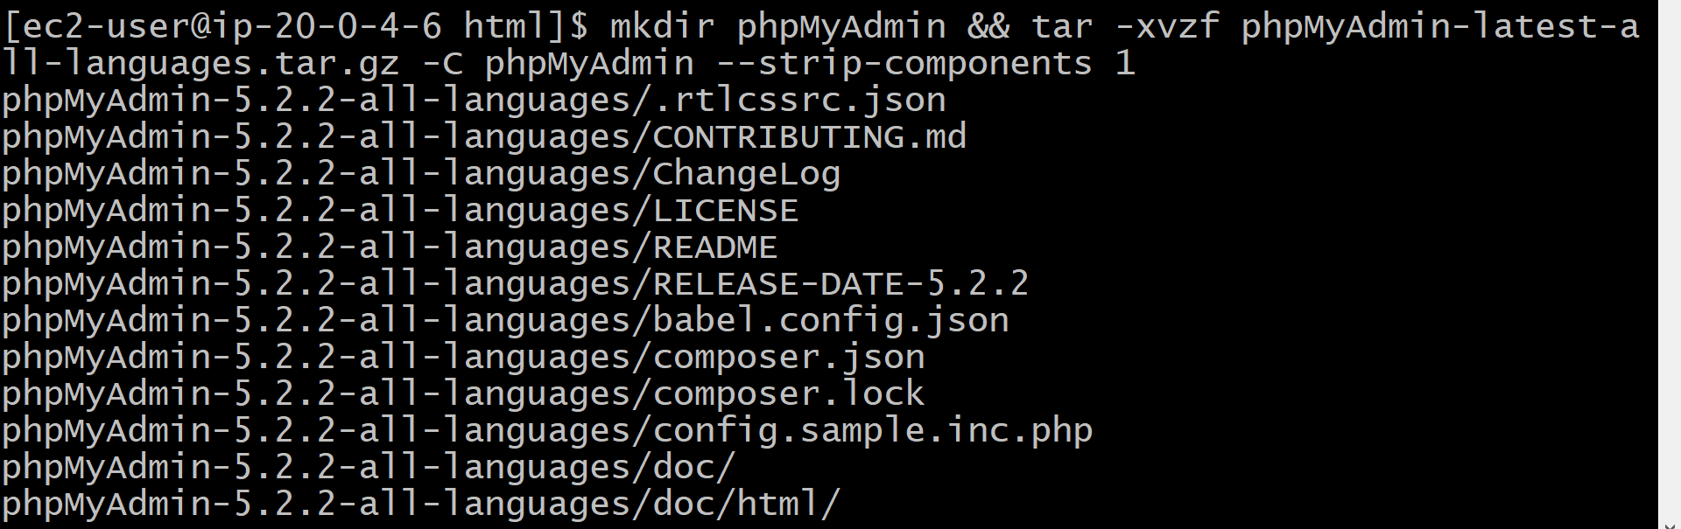

>> rm phpMyAdmin-latest-all-languages.tar.gz
# Create a Test Page and Test the Server
>> echo "PHP server 2" > /var/www/html/index.html
>> curl http://localhost
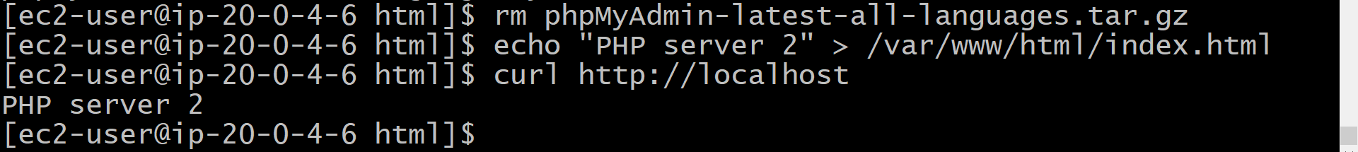

4. Create the Target groups:

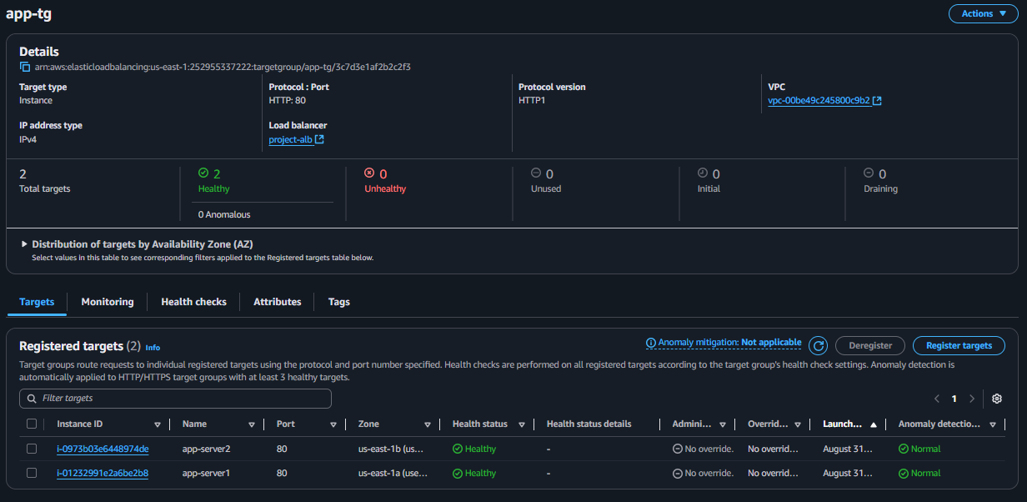

5. Create Application Load Balancer
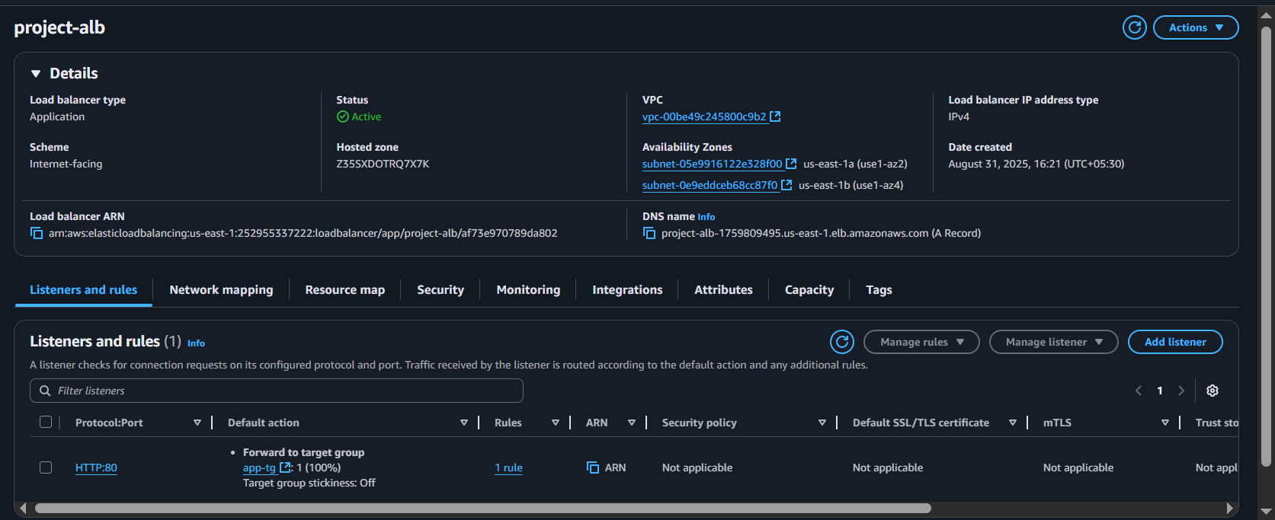

6. Test the Load balancer : Now take the load balancer DNS and past it on chrome browser you should see PHP Server 1 and when you refresh the page it should show PHP Server 2 that means your load balancing is working as expected

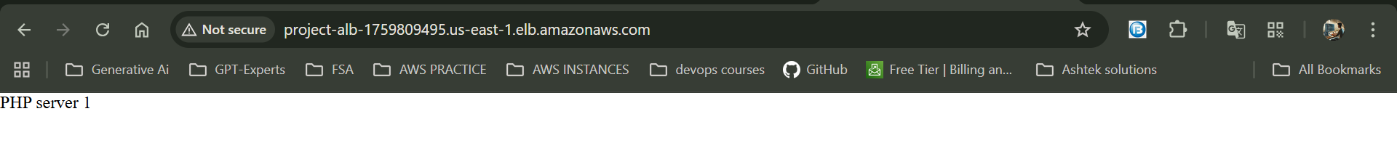
Refrest the page:

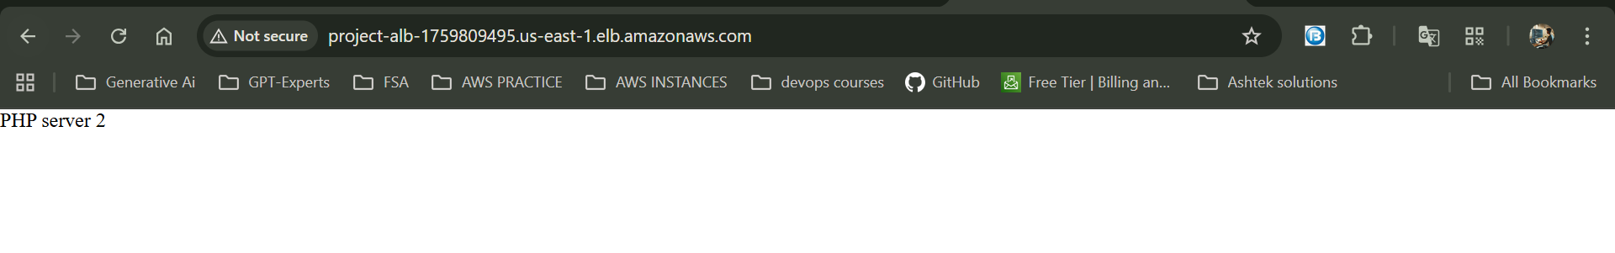

7. Check PhpMyAdmin :- And when you write phpMyAdmin after your domain name it should navigate to
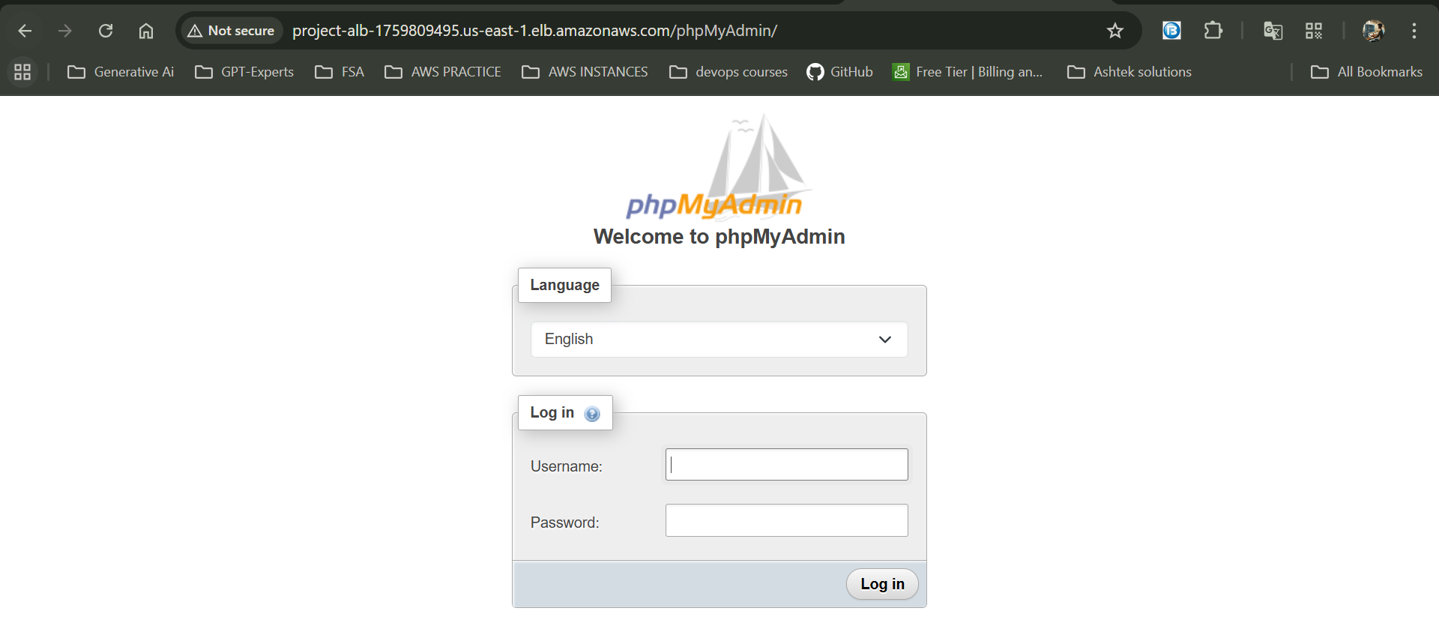

Part 4 :- Database configurations
Now copy the Endpoint of RDS cluster and ssh into app-server1 instance and app-server2 instance
>>cd /var/www/html/phpMyAdmin
>> mv config.sample.inc.php config.inc.php
>> nano config.inc.php
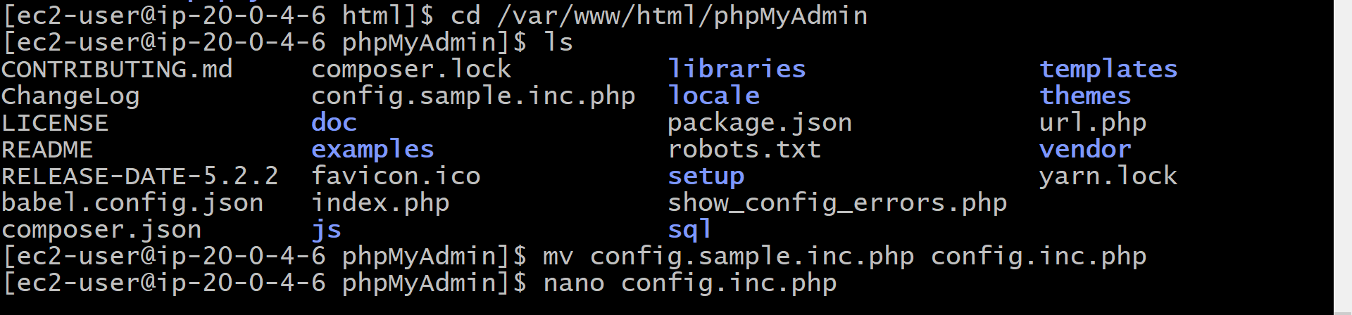
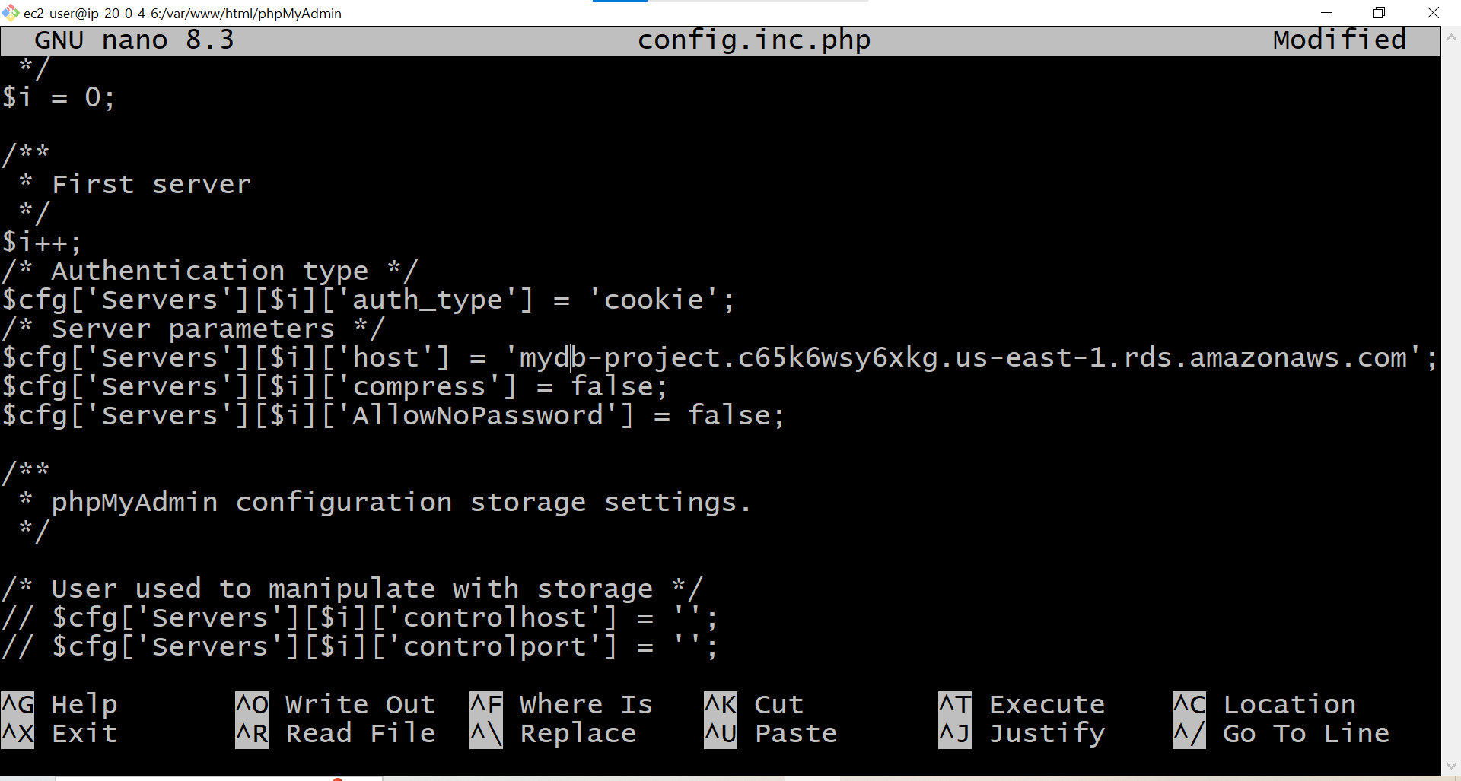

Once you enter your username and password:
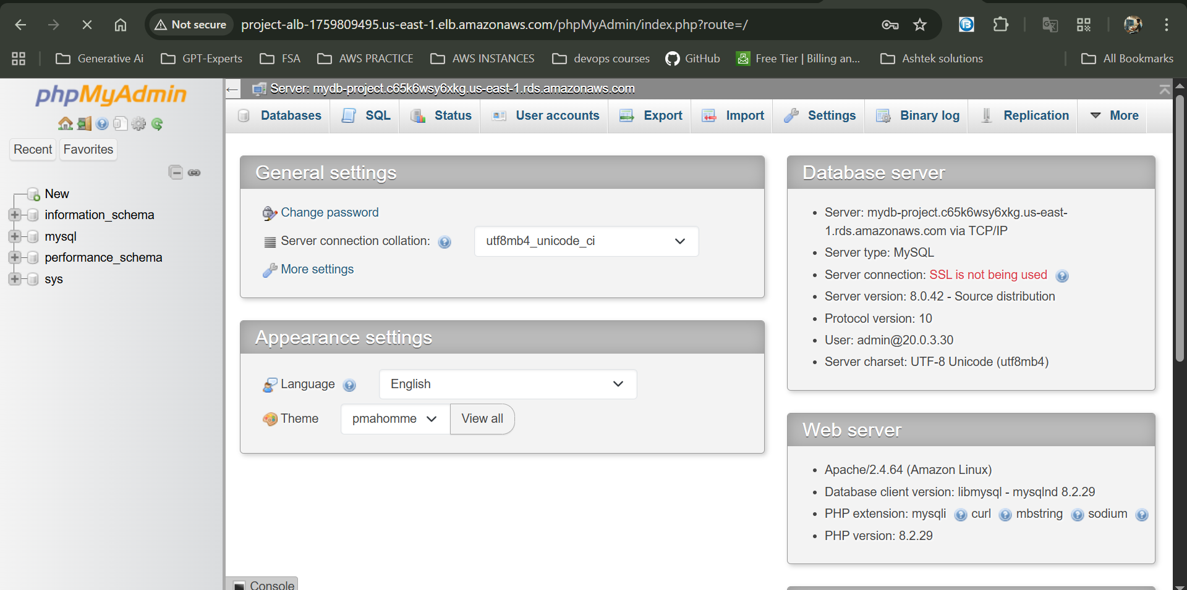

The end

